Ice Cream Manager [ICM]

Use Case Specification Document

Use Case ID: 07

Modify Driver

Version No. v0.4

Project Document Revision History

|  |  |  |  |
| --- | --- | --- | --- |
| Version | Date | Revision Author | Description of Revision |
| 0.1 | 2016-2-20 | Rodney Lewis | Initial content generation. |
| 0.2 | 2016-2-26 | Rodney Lewis | Added sections 1.0, 2.1, 2.2, 3.0, 4.0 |
| 0.3 | 2016-3-4 | Rodney Lewis | Added sections 5.0, 6.0, 7.0, 8.0, 9.0 |
| 0.4 | 2016-3-5 | Rodney Lewis | Added description to section 7.0, updated section 6.0/7.0. Updated section 2.2 with successors. Updated TOC. |
|  |  |  |  |

Table of Contents

1.0 Introduction 4

2.0 Use Case Information 4

2.1 Actors 4

2.2 Use Case Interaction 4

3.0 Trigger 4

4.0 Pre-condition(s) 4

6.0 Use Case Activity Diagram 5

6.1 Edit driver 5

6.2 Display Sales 6

7.0 Main/Basic Flow(s) of Events 7

7.1 Set name 7

7.2 Display sales 7

8.0 Alternate/Exception Flow of Events 7

8.1 Set name 7

8.2 Display sales 7

9.0 Assumptions/Business Rules including Non-Functional Requirements 7

10.0 Use Case Specification Review and Signoff 8

# 1.0 Introduction

Allows user to modify driver information. Able to set the drivers name and set their salary. Drivers will be assigned to trucks initially and can be moved to different trucks by user. The sales of the driver can be displayed through a daily or weekly view.

# 2.0 Use Case Information

## 2.1 Actors

|  |  |  |
| --- | --- | --- |
| Actor Name | Role | Description |
| Manager | Main | Person responsible for the management of trucks and ice cream distribution |

## 2.2 Use Case Interaction

* Predecessor
  + Process batch file
* Successor
  + Modify inventory
  + View sales
  + Modify route
  + Modify truck
  + Modify item
  + Modify driver
  + Modify settings
  + Modify voting
  + Modify presets
  + View fuel usage

# 3.0 Trigger

Triggered through user choosing to modify the aspects of their drivers

# 4.0 Pre-condition(s)

**4.1** Process batch file must be executed before modify drivers can be used

**5.0 Post-condition(s)**

**5.1** Driver sales by day or week display

**5.2** View driver roster

# 6.0 Use Case Activity Diagram

## 6.1 Edit driver

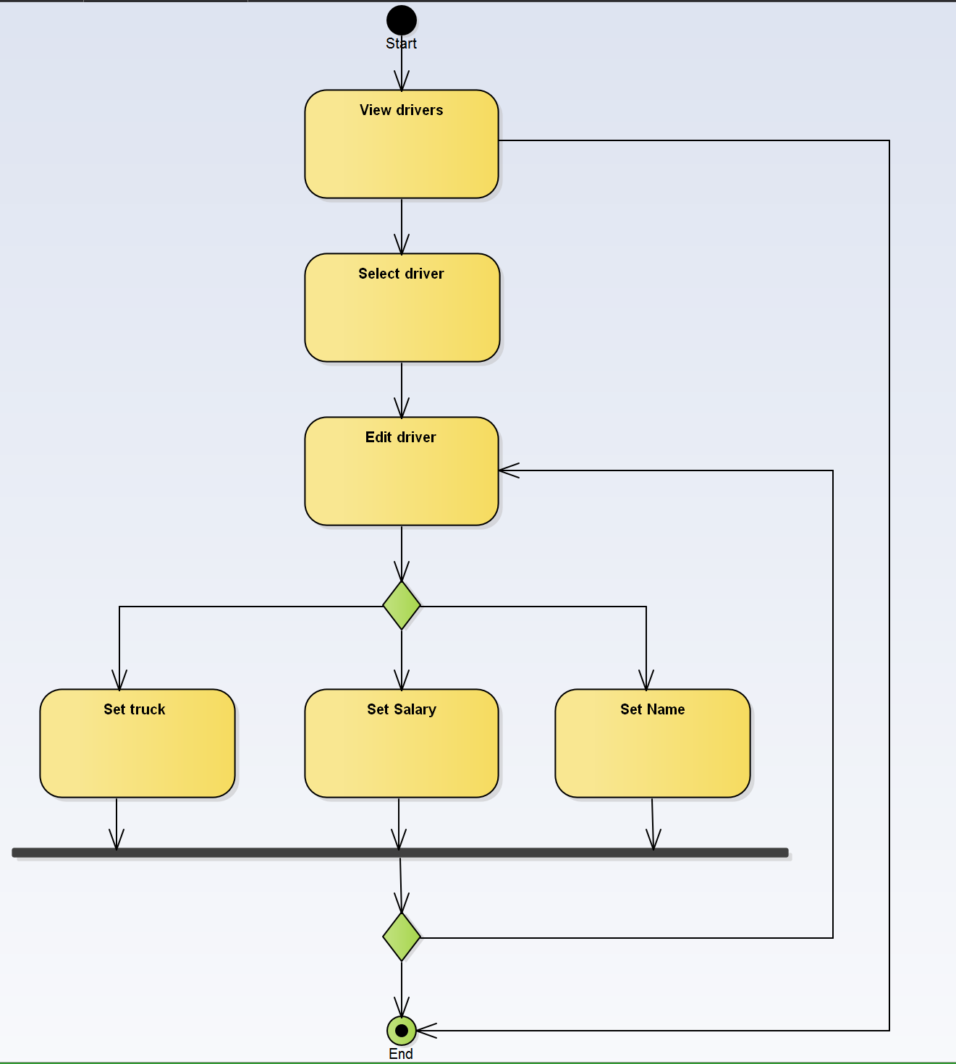

## 6.2 Display Sales

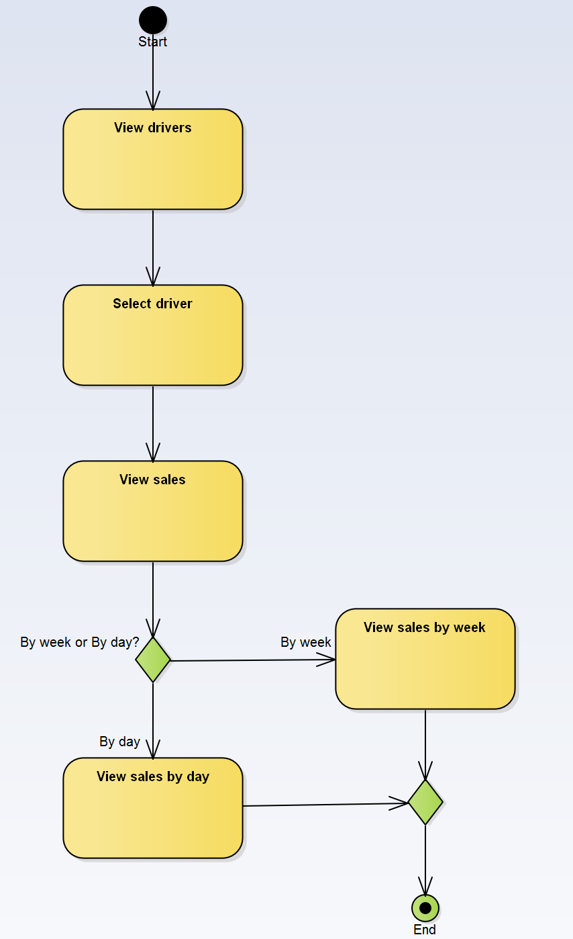

# 7.0 Main/Basic Flow(s) of Events

## 7.1 Set name

1. View drivers: User views driver list
2. Select driver: Select a single driver from the driver list
3. Edit driver: Chose to edit that driver
   1. Set truck OR
   2. Set name OR
   3. Set salary

## 7.2 Display sales

1. View drivers: User views driver list
2. Select driver: Select a single driver from the driver list
3. View sales: View the driver’s sales by week or by day
   1. By week
   2. By day

# 8.0 Alternate/Exception Flow of Events

## 8.1 Set name

* From view drivers can proceed to end.
* From last decision can procced to back to edit driver.

## 8.2 Display sales

None

# 9.0 Assumptions/Business Rules including Non-Functional Requirements

None

# 10.0 Use Case Specification Review and Signoff

Review and Signoff of the Use Case Specification

|  |  |  |  |
| --- | --- | --- | --- |
| Name | Project Team Role | Signature | Date |
| Camille Williams | Project Manager |  |  |
| Marc King | Team Lead |  |  |
|  |  |  |  |